Appendix -1
Snap shots of Project Team at Work/Results

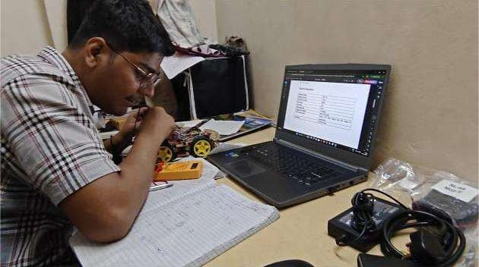
Figure 2.1 Team Leader (Ketan Sunil Rakhe)

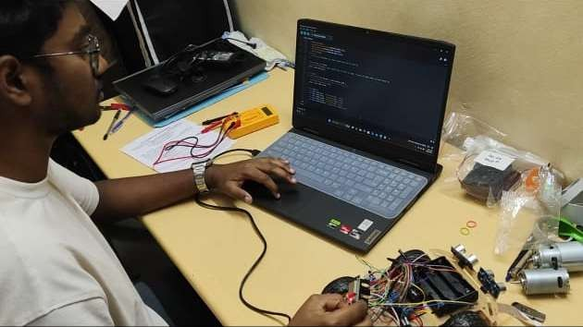
Figure 2.2 Member 1 (Krish Rajesh Tagram)

Department of E&TC Engineering DEC-2025 P a g e | 35

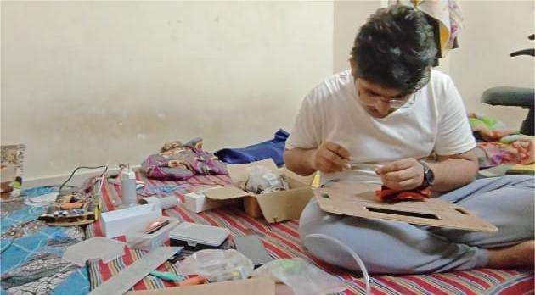
Figure 2.3 Member 2 (Rushikesh Rahul Chavhan)

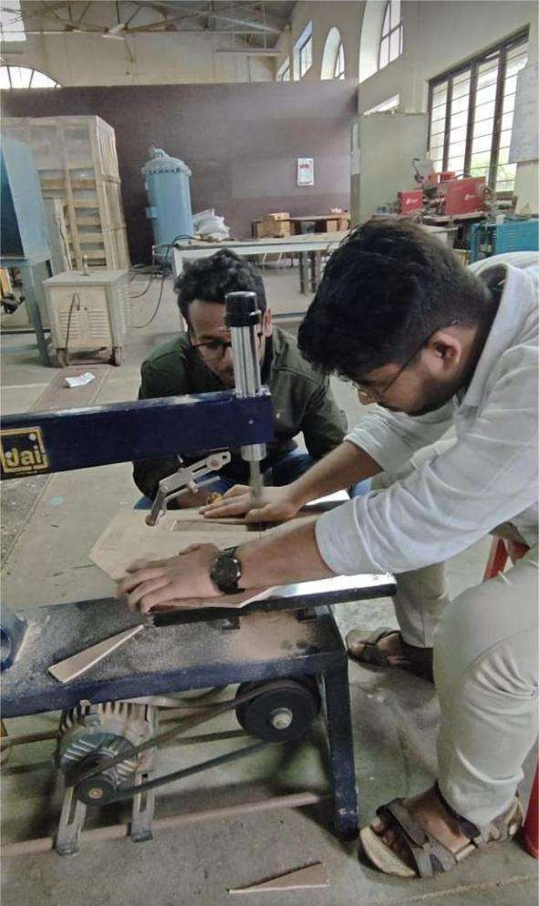
Figure 2.4 Member 2 (Rushikesh Rahul Chavhan)

Appendix -2 Pseudo code

Department of E&TC Engineering DEC-2025 P a g e | 37

Pseudo Code for HexaBot

BEGIN

INITIALIZE ESP32
INITIALIZE ultrasonic sensors, IR sensors, IMU, motor drivers, dust sensor INITIALIZE cleaning motors (rollers, suction, side brushes)
INITIALIZE battery monitoring system SET bot_mode = CLEANING

WHILE bot_mode == CLEANING:

READ ultrasonic distance values READ IR edge detection values READ IMU tilt and angle READ battery voltage

// Navigation Logic
IF obstacle_detected(): STOP drive motors REVERSE for short delay
ROTATE left or right based on free space ELSE:
MOVE_FORWARD at normal speed

// Edge Protection
IF IR detects edge or drop: STOP
REVERSE slightly TURN to safe direction

// Cleaning System Control
ACTIVATE suction motors at full speed ACTIVATE roller brushes
ACTIVATE side brushes

// Stability Check
IF IMU detects tilt beyond safe angle: STOP all motors
SEND alert (optional)

// Battery Check IF battery_low():
STOP cleaning motors
RETURN to base or STOP operation END WHILE

STOP all motors
SAVE logs (optional)END

Department of E&TC Engineering DEC-2025 P a g e | 39

Appendix -3 Datasheets

Datasheets

- ESP32 WROOM-32 Module
https://www.espressif.com/sites/default/files/documentation/esp32-wroom- 32_datasheet_en.pdf
- HC-SR04 Ultrasonic Sensor https://cdn.sparkfun.com/datasheets/Sensors/Proximity/HCSR04.pdf
- IR Sensor – TCRT5000
https://www.vishay.com/docs/83751/tcrt5000.pdf
- MPU6050 IMU
https://invensense.tdk.com/wp-content/uploads/2015/02/MPU-6000-Datasheet1.pdf
- L298N Motor Driver https://www.st.com/resource/en/datasheet/l298.pdf
- 775 DC Motor https://components101.com/motors/775-dc-motor
- N20 Geared Motor https://components101.com/motors/n20-gear-motor
- Li-ion 3S Battery Pack https://batteryuniversity.com/
- Centrifugal Blower Motor https://www.elecrow.com/download/Centrifugal%20Blower.pdf
- Optical Dust Sensor https://cdn.sparkfun.com/datasheets/Sensors/Proximity/gp2y1014au0f.pdf

Department of E&TC Engineering DEC-2025 P a g e | 41

Appendix -4 Reviews/Assignments and Activities

Reviews / Assignments and Activities
This section documents the weekly progress, team activities, mentor interactions, component testing, and design iterations carried out throughout the development of HexaBot – Autonomous Cleaning Robot. It provides evidence of consistent work, learning, and systematic progress during the project duration.

Table 6.1 Weekly Progress Review Table

Week | Activities Completed | Team Members Involved | Remarks / Mentor Feedback
Week 1 | Problem definition, requirement analysis, and component research | All | Define clear objectives and target constraints
Week 2 | Selection of sensors, motors, and power system | Power &  Electronics Lead | Ensure compatibility before purchase
Week 3 | Initial block diagram & system architecture | Embedded Systems Lead | Improve clarity of signal flow
Week 4 | CAD modeling of chassis & cleaning mechanism | Mechanical Lead | Add mounting for dust container
Week 5 | PCB design for ESP32 controller board | Power Lead | Check track widths for motor currents
Week 6 | Sensor integration (ultrasonic, IR, IMU) | Embedded Lead | Test under different lighting conditions
Week 7 | Motor driver configuration & PWM tuning | Power + Control Team | Avoid overheating during long runs
Week 8 | Prototype assembly (mechanical + electrical) | Full Team | Tighten wiring and cable routing
Week 9 | Testing cleaning mechanism (brush + suction) | Mechanical + Power | Increase airflow for fine dust
Week 10 | Full system integration and runtime evaluation | All | Bots meets minimum runtime criteria
Week 11 | Competition-oriented tuning & obstacle tests | Control Algorithms Lead | Navigation improved considerably
Week 12 | Final review, documentation & report completion | All | Prepare for presentation

- Mentor Feedback Summary
  - Improve obstacle detection threshold for narrow spaces.

Department of E&TC Engineering DEC-2025 P a g e | 43

  - Increase chassis strength using additional reinforcement.
  - Maintain logs of battery discharge cycles.
  - Optimize suction motor duty cycle for longer runtime.
  - Keep mechanical tolerances consistent in the cleaning module.
Mentor was satisfied with the overall progress and appreciated the team’s systematic approach.

Table 6.2 Task Distribution Table

Team Member | Role | Major Responsibilities
Rushikesh Chavhan | Mechanical Design Lead | CAD modeling, chassis design, roller mechanism
Krish Tagram | Embedded Systems Lead | ESP32 programming, , PCB design, Navigation logic
Ketan Rakhe | Power & Electronics Lead | Battery system, motor drivers, Documentation
Priyanka Mugutmal | Control & Testing Lead | sensor interfacing, test reports, debugging

- Activity Logs
  - Conducted sensor calibration sessions every week.
  - Assembled two mechanical prototypes for testing.
  - Performed multiple indoor navigation trials with obstacles.
  - Measured dust pickup rate for different floor surfaces.
  - Logged battery consumption data for runtime predictions.

Table 6.3 Component Testing Results

Component | Testing Performed | Result
Ultrasonic sensors | Distance accuracy & blind spot tests | Passed
IR sensors | Edge detection & floor reflection tests | Passed; minor variation noted
IMU | Tilt angle detection | Stable readings
Suction motors | Airflow & load current test | Strong airflow; high current draw
Side brushes | Rotation & debris pushing test | Effective for corners
ESP32 | Communication & PWM output | Stable, low-latency control

- Mechanical Design Snapshots
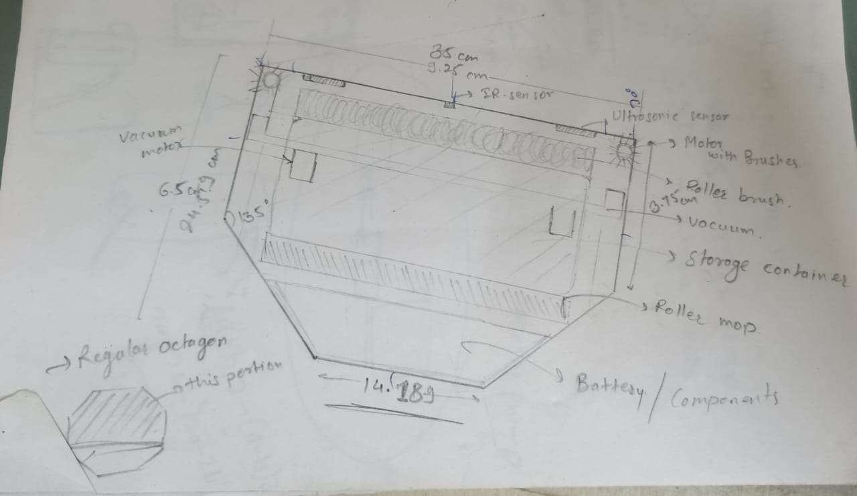
Figure 3.1 Skecth of HexaBot 1

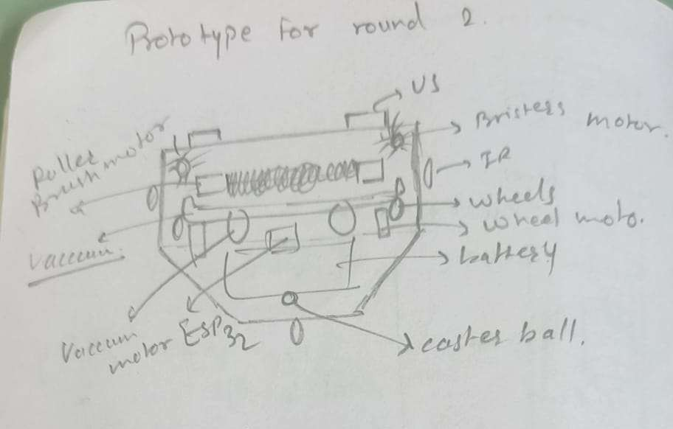
Figure 3.2 Skecth of HexaBot 2

Department of E&TC Engineering DEC-2025 P a g e | 45

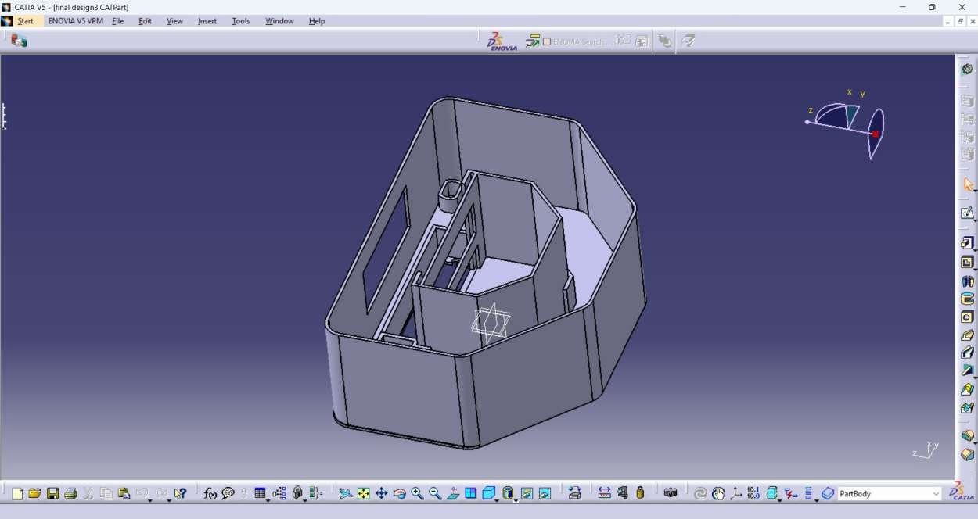
Figure 4.1 CAD Model of HexaBot

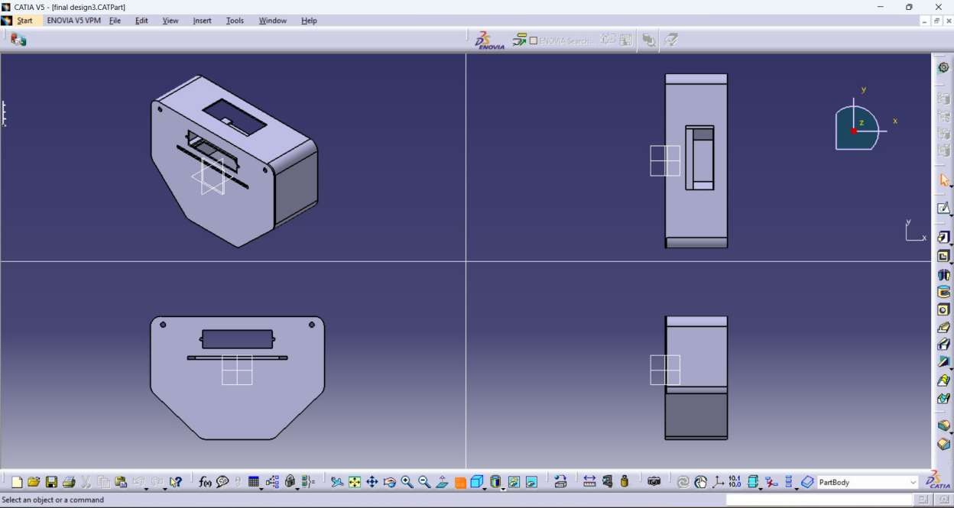
Figure 4.2 Different Views of CAD Model of HexaBot

- Simulation Screenshots
  - Motor driver test signals
  - Sensor range simulation
  - Navigation path visualization
  - Suction performance graph (if any)

- Prototype Development Photos
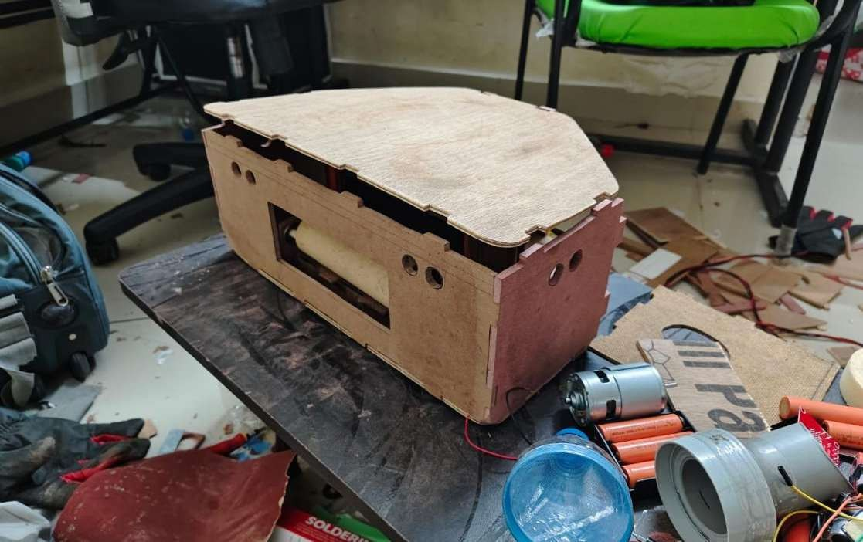
Figure 5.1 Fully assembled body of hexabot

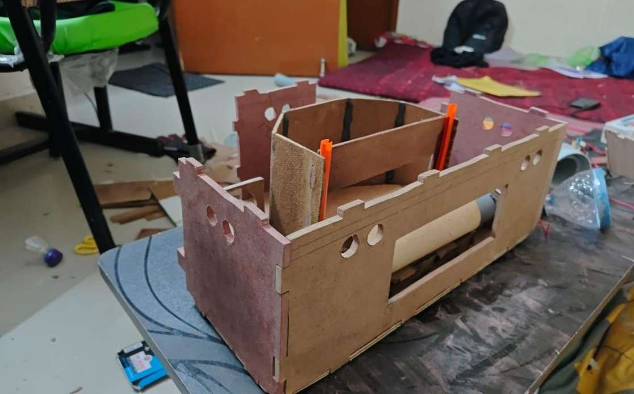
Figure 5.2 Side shot semi assembled body of hexabot (waste bin is visible)

Department of E&TC Engineering DEC-2025 P a g e | 47

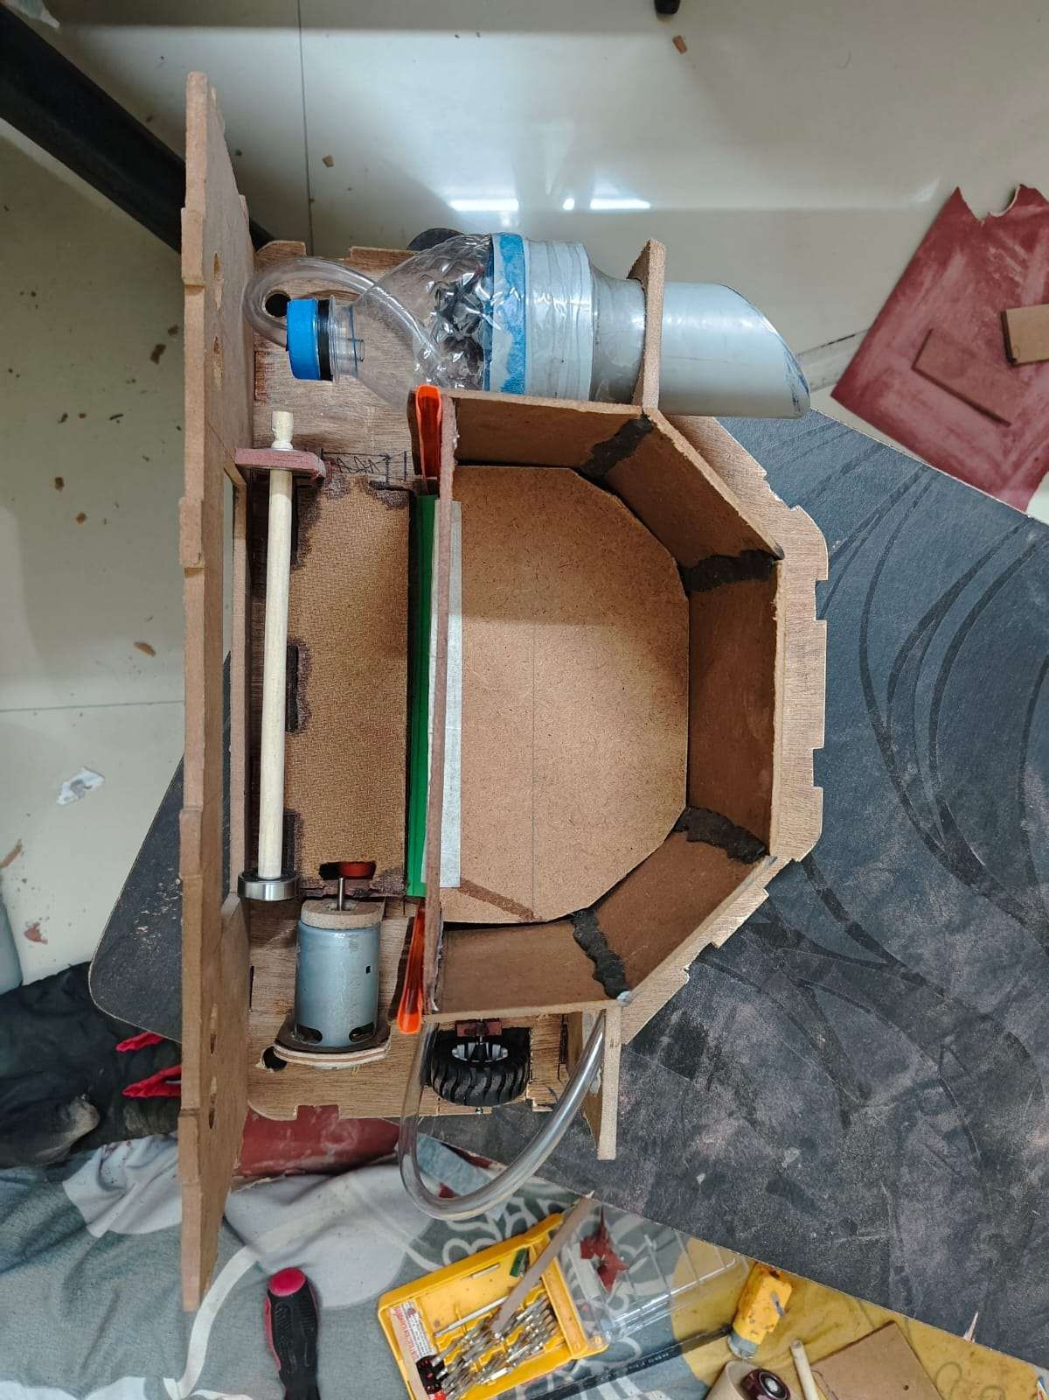
Figure 6.1 Top view of Hexabot

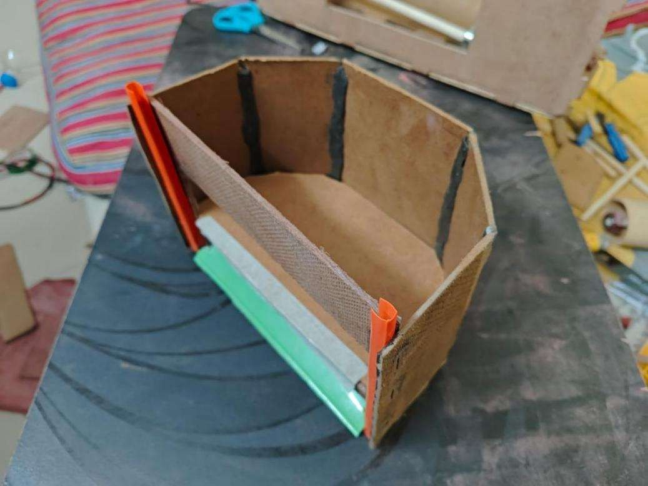
Figure 6.2 Detachable waste bin of Hexabot
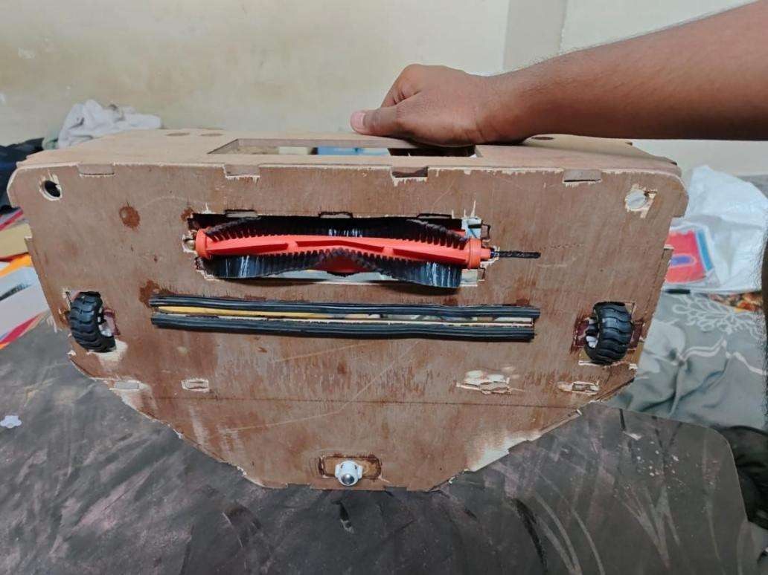
Figure 6.3 Bottom view of Hexabot

- Team Contribution Summary
  - All members contributed equally in design, wiring, testing, and documentation.
  - Weekly review meetings ensured progress and helped solve issues faster.
  - Tasks were rotated so each member gained interdisciplinary experience.

Department of E&TC Engineering DEC-2025 P a g e | 49

Power point presentation of Review 1:
https://docs.google.com/presentation/d/1rMs4CGqNxxvZ5PSqow36f7wT2eVygeGm/edit?usp=sharin g&ouid=114176931882097213346&rtpof=true&sd=true

Power point presentation of Review 2:
https://docs.google.com/presentation/d/1_eoAwX0CcIti_XfOQaoBkWEivjAp6Mqp/edit?usp=sharing &ouid=114176931882097213346&rtpof=true&sd=true

